Tourism Sustainability Grant Application

State of Washington Tourism (SWT) is committed to the full recovery of the tourism sector in the wake of the coronavirus pandemic, and it has prioritized industry segments within the sector to hasten and maximize recovery efforts. As tourism continues to rebound toward pre-pandemic levels, the Tourism Sustainability Grant program will foster safer, more inclusive, and sustainable visitor experiences in the State of Washington.
Washington-based tourism stakeholders may request up to $30,000 in grant funding based on project eligibility. They must submit a complete and thorough application with details on project objectives, longevity, and budget. If awarded grant funding, the grantee must submit all contracts/contractors involved with each project to SWT for review and approval. The total funding available for the Tourism Sustainability Grant program is $200,000.
Though not required for this grant, applicants are strongly encouraged to match a portion of their grant request with cash or in-kind contributions. Grant funds from SWT should not pay for staff salaries, debt, or interest payments associated with eligible projects. Applicants are also strongly encouraged to collaborate with local destination marketing organizations and other tourism-related partners on eligible projects.
SWT will accept applications for the Tourism Sustainability Grant between August 15 – September 15, 2022. A review committee of industry experts will evaluate the leading grant applications and SWT will announce award decisions by September 30 via email. Grant funds must be expended by August 1, 2023.
SWT will release grant funds as a lump sum to awardees upon approval of their grant applications. Awardees will be expected to submit a project evaluation by October 1, 2023. If awardees fail to submit an evaluation, their consideration for future grants may be adversely affected. Each project evaluation should include a final budget, proof of spending, photos, and a written account of how grant funds were used and their impact on travel and tourism.
The grantee must acknowledge the Tourism Sustainability Grant program and include the SWT logo in material associated with the grant project. SWT must also review and approve this material.

Applicant Information
- Entity: ____________________________________________________________________________________________________

- Federal Tax Identification Number: ____________________________________________________________________

- Mailing Address: ________________________________________________________________________________________

- Phone Number: _________________________________________________________________________________________

- Contact Name: ___________________________________________________________________________________________

- Contact Email Address: _________________________________________________________________________________

- Contact Phone Number: ________________________________________________________________________________
- Destination Marketing Organization(s) in your area_________________________________________________

Project Information
- Title: ______________________________________________________________________________________________________
- Grant Amount Requested: ______________________________________________________________________________
- Total Cost: ________________________________________________________________________________________________

- Project Category (select one):
____ Capital Projects
____ Festivals and Events
____ Outdoor Recreation
____ Business Districts and Main Street Associations
____ Other (please describe below)
__________________________________________________________________________________________________________
- Select the tourism region(s) for the project:
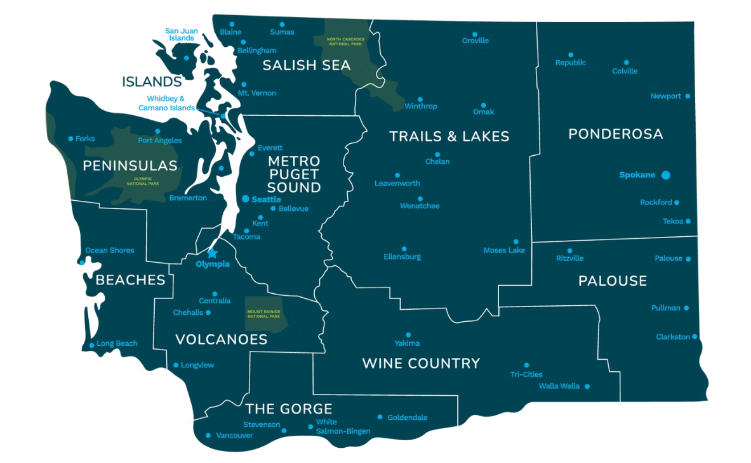
____ Islands

____ Peninsulas

____ Beaches

____ Salish Sea

____ Metro Puget Sound

___ Volcanoes

___ The Gorge

___ Trails and Lakes

___ Wine Country

___ Ponderosa

___ Palouse

Application Questions
Limit responses to no more than 400 words.
- Provide a project description including objectives, budget, partners, and statement of need:

- How will this project foster safer, more inclusive, or sustainable visitor experiences in the State of Washington?

- Describe the project timeline and evaluation metrics. This project must either be completed by August 1, 2023 or have grant funds expended by that date.

- Have the required construction permits for this project been identified and secured?
_____ Yes
____ No
_____ N/A

Supporting Documents

Applicants must provide proof of their Employer Identification Number (EIN) from the IRS in the form of a verification letter. For more information on verification letters, contact the IRS Tax Exempt and Government Entities Customer Account Services (877-829-5500). Applicants must also submit a completed SWT Substitute W-9 Form as well as a grant budget with the SWT template.

Optional Documents
Along with this application form, applicants may also submit letters of support, architectural drawings, site plans, receipts/quotes, and other documents that provide additional context for the review committee.
Signature and Submission
Applicants must understand and agree to the criteria for the Tourism Sustainability Grant program. They must also complete this grant application with integrity and accuracy and send all materials to matthew@stateofwatourism.com by 5 p.m. on September 15, 2022. Please include “Tourism Sustainability Grant Application” in the subject line.

____________________________________________________ _____________________
[Name] Date
[Title]

